Name: Trần Anh Tuấn
Student ID: 24521943
Class: CS4323.Q12.CTTT – CTTT2024

OS
LAB 1

CHECKLIST
1. Homework
 | 1 | 2 | 3 | 4 | 5 | 6
Explanation
Your code
Results and discussions

Mark: 10/10
2. Lab 1 Execute, google, and explain usage of all commands in this section
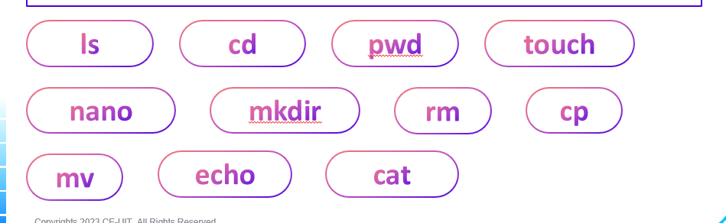
Answer:
- ls – List files and directories
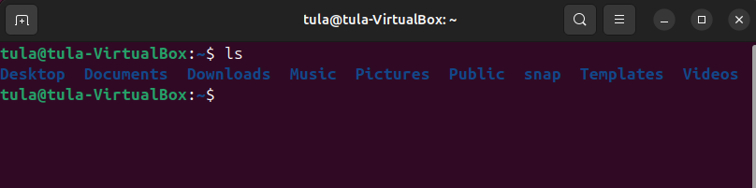
Usage: ls [directory]
Purpose: Displays files and folders in the current or specified directory.

- cd – Change directory
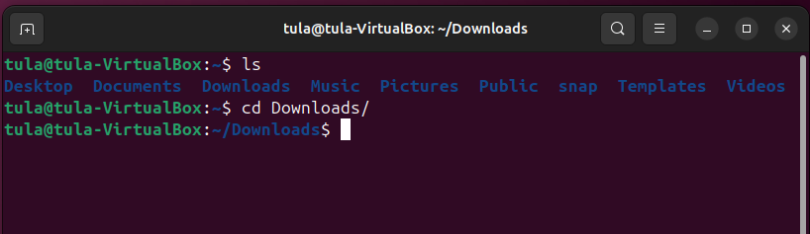
Usage: cd [directory]
Purpose: Moves you from your current directory to another.

- pwd – Print working directory
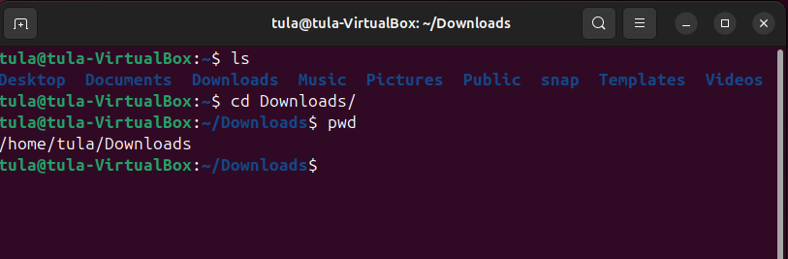
Usage: pwd
Purpose: Shows the full path of your current directory.

- touch – Create empty files
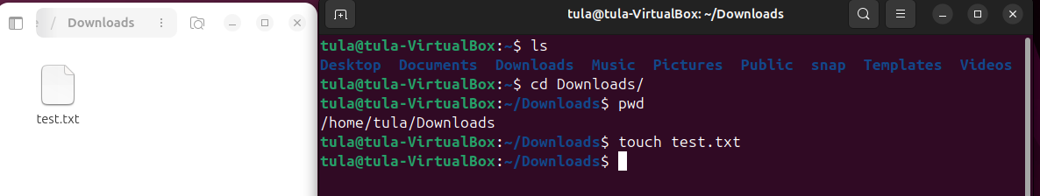
Usage: touch [filename]
Purpose: Creates an empty file or updates the modification time of an existing file.

- nano – Text editor
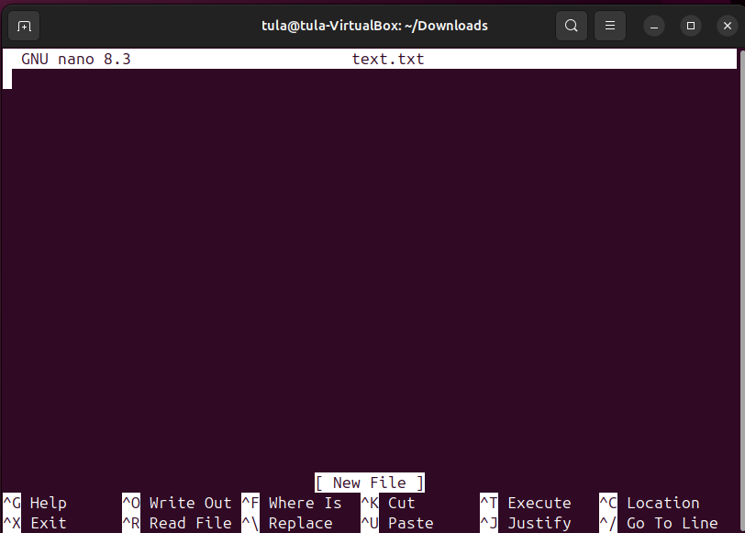
Usage: nano [filename]
Purpose: Opens a text-based editor in the terminal to edit files.

- mkdir – Make directory
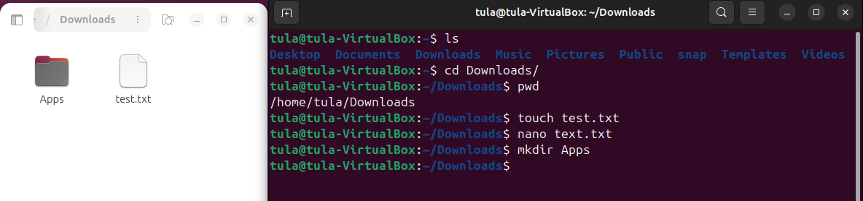
Usage: mkdir [directory_name]
Purpose: Creates a new folder.

- rm – Remove files or directories
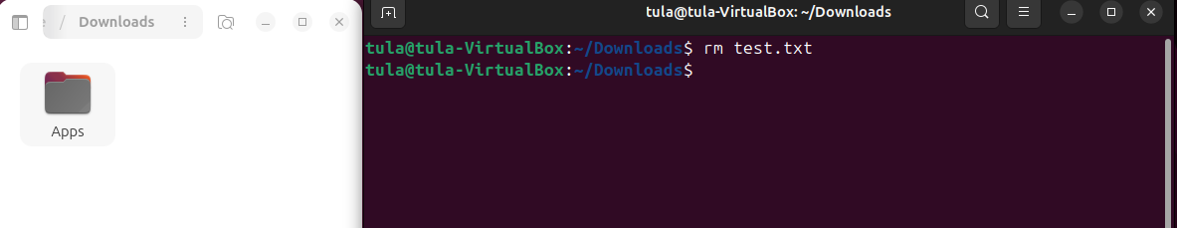
Usage: rm [options] [file]
Purpose: Deletes files or folders.
- cp – Copy files or directories
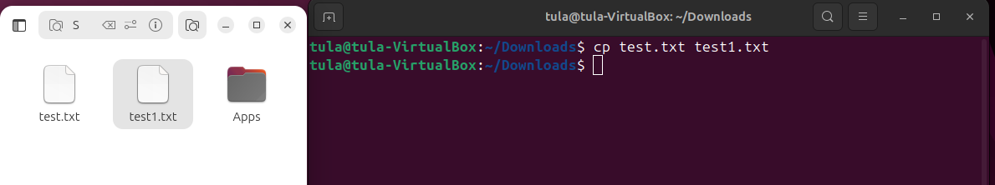
Usage: cp [source] [destination]
Purpose: Copies files or folders.
- mv – Move or rename files
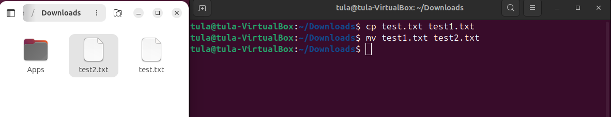
Usage: mv [source] [destination]
Purpose: Moves or renames files or directories.
- echo – Print text to terminal or file
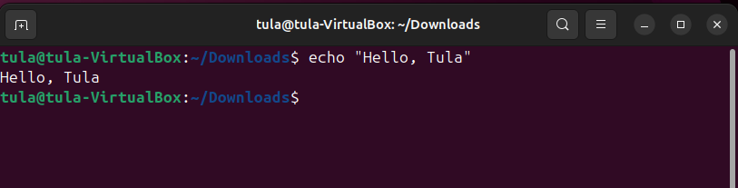
Usage: echo [text]
Purpose: Displays text or writes it to a file.

- cat – Concatenate and display file content
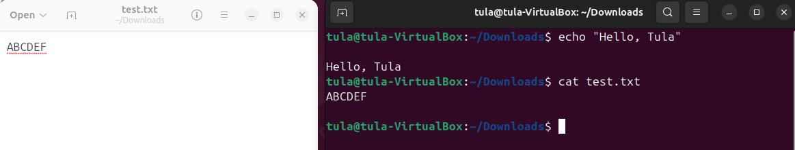
Usage: cat [file]
Purpose: Shows the content of a file or combines multiple files.
2. Create a folder tree like image below:
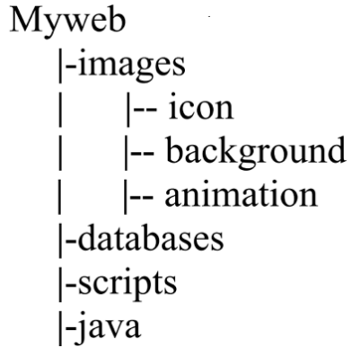
Answer:
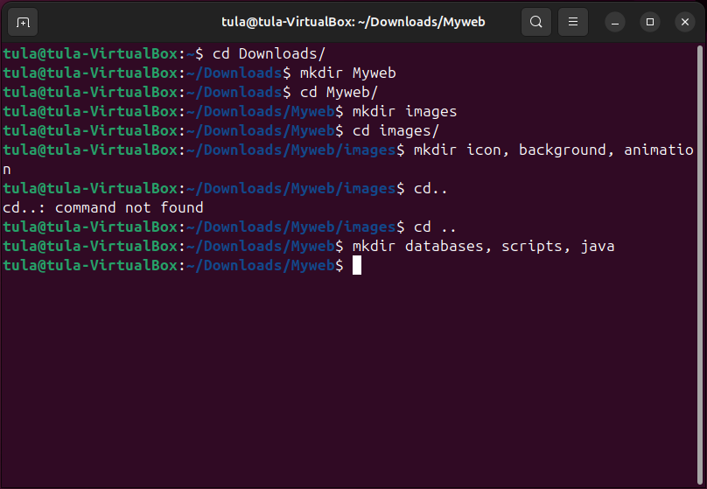
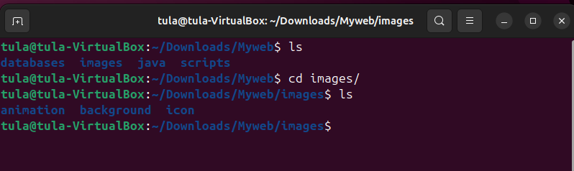
Explanation:
- mkdir Myweb → creates a main folder named Myweb.
- cd Myweb → moves inside the Myweb folder.
- mkdir images → makes a folder called images inside Myweb.
- cd images → moves into the images folder.
- mkdir icon background animation → creates three subfolders: icon, background, and animation.
- cd .. → goes back one level to the Myweb directory.
- mkdir databases scripts java → creates three more folders: databases, scripts, and java.

3. Google how to find files with the “.html” extension in your entire system. Copy one of them to Myweb.
Answer:
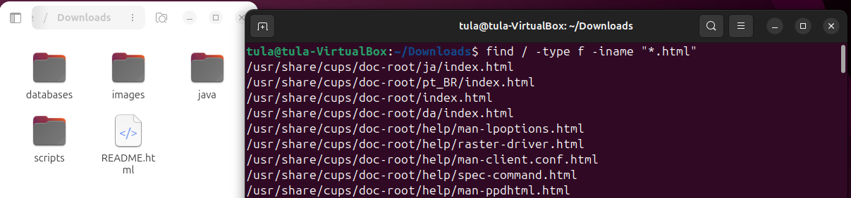
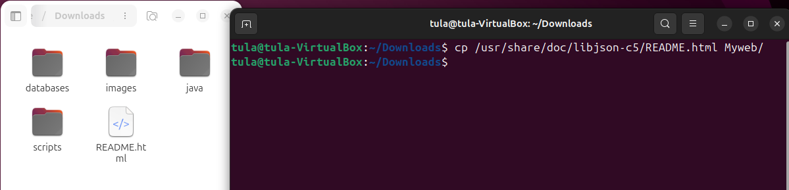
Explanation:
find / -type f -name "*.html": This command searches from the root directory / for all regular files (-type f) whose names end with .html.
cp /usr/share/doc /libjson-c5/README.html Myweb/: This command copy the file into the Myweb folder.

4. Remove the directory Myweb/scripts.
Answer:
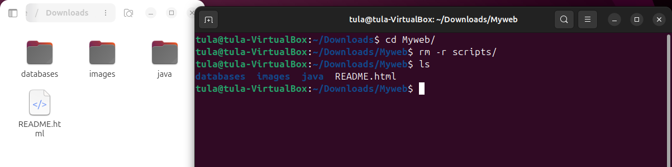
Explanation:
rm -r Myweb/scripts: The rm command removes files or directories, while the -r option enables recursive deletion, allowing all contents within the directory to be removed.

5. Set the permission for Myweb/databases as below:
- The owner has all permissions
- Other users have no permission
Answer:
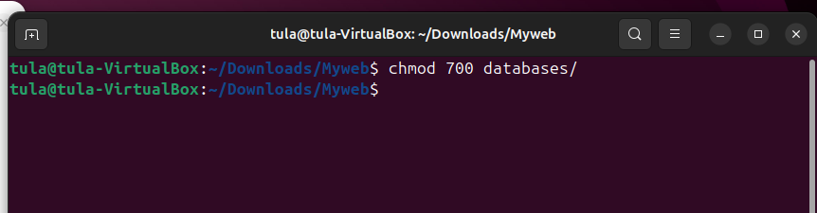
Explanation:
chmod 700 Myweb/databases:
The chmod command modifies access rights.
- The first number 7 grants the owner read (r), write (w), and execute (x) permissions.
- The second 0 remove all permissions from the group.
- The third 0 remove all permissions from other users.

